EEE/CSE 120
Answer Sheet
Capstone Design Project
Name:____Pragathi Gopal________
Instructor:__Chickamenahalli_______
Class Time:_7:30am -8:45am______
Date:_11/7/16______________

Task 4-1: Design of Synchronous Sequential Machines
Design #1 (Mealy machine): What assumptions did you make in the design of this machine?________ Within the Mealy design, I assumed that there isn’t a way to go back to the previous state. Essentially, the Mealy design has each state that is passed to the next one whenever the players score a point. Thus, the outputs in the Mealy machine are connected to the inputs and the clock stops when a player wins and does not start until it is reset again.
Create a state definition table here that describes in plain English what each state in your machine means and what binary values you have assigned to represent each state.
State | Meaning | Binary Values
A | Reset button | 00
B | Player 1 is ahead in the game by one point | 01
C | Player 2 is ahead in the game by one point | 10
D | Winner is declared and the score is reset | 10 or 01

Create tables here to display your state diagrams, state transition tables and Karnaugh maps used in your design process. (You can do this by hand if you wish.)
Please refer to the attached document

Cut and paste your Logisim design#1 (Mealy machine) circuit here:
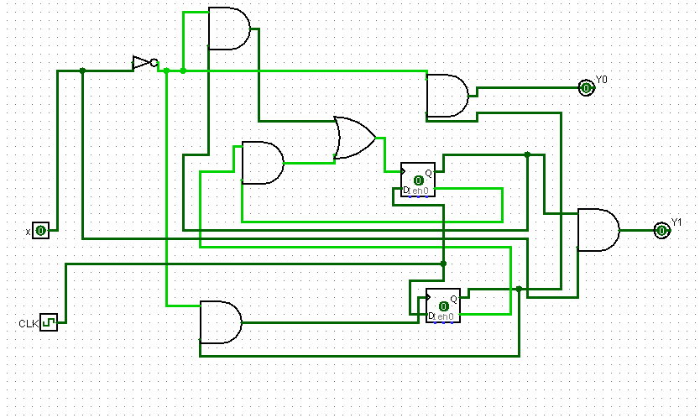

Design #2 (Moore machine): What assumptions did you make in the design of this machine?
The Moore machine the outputs are connected to the states in the machine rather than the inputs. For the Moore machine, I essentially assumed that there is not a way to go back to the previous state after the final state is reached.
Create a state definition table here that describes in plain English what each state in your machine means and what binary values you have assigned to represent each state.

State | Definition | Binary Value
A | Reset state | 000
B | When player 1 is ahead 1 point | 001
C | When player 2 is ahead 1 point | 010
D | Player 1 wins | 011
E | Player 2 wins | 100

Create tables here to display your state diagrams, state transition tables and Karnaugh maps used in your design process. (You can do this by hand if you wish.)
Please refer to the attached document
Cut and paste your Logisim design #2 (Moore machine) circuit here:
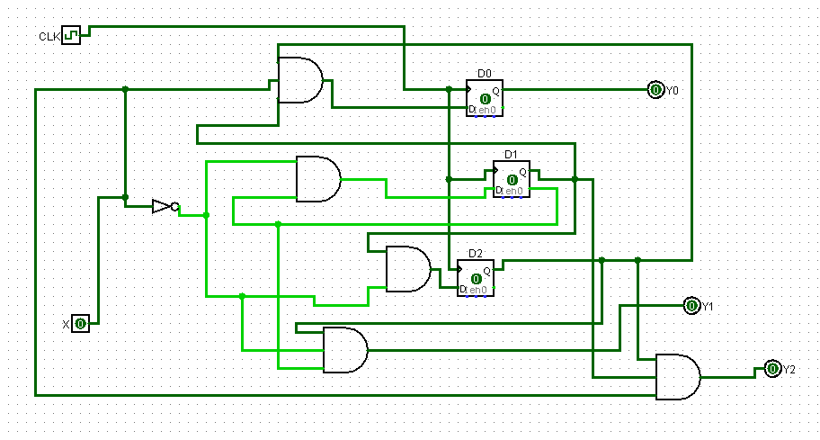

Task 4-2: Simulate Both Designs
Demonstrate that both of your circuits meet the completed design specification to a laboratory assistant and have the TA apply a grade here, and on the grade sheet and have them sign their name.
Signature ________________________ Grade: 1st Design ____/15 Grade: 2nd Design____/15
Task 4-3: Determine Criteria and Weighting for Judging Your Designs
Using the guidelines in the laboratory manual, list your criteria and associated weights here:
Criteria Weight

Task 4-4: Apply the Criteria to Pick the Best Design
Describe how you applied the criteria and weighting system in the above task to pick the best design.

Which design is better based on your criteria and weighting system?__________________________

Task 4-5: Build One Design in the Laboratory
Demonstrate to a laboratory assistant that one of your designs works according to your completed specification.
Laboratory assistant evaluation: _____________________

Capstone Design Project: Lab Report Grade Sheet

Name: | Pragathi Gopal

Instructor Assessment: Task Oriented
Grading Criteria | Max Points | Points lost
Template
Neatness, Clarity, and Concision | 5
Description of Assigned Tasks, Work Performed & Outcomes Met
Task 4-1: Design of Synchronous Sequential Machines | 22
Task 4-2: Simulate Both Designs | 30
Task 4-3: Determine Criteria and Weighting for Judging Your Designs | 5
Task 4-4: Apply the Criteria to Pick the Best Design | 8
Task 4-5: Build One Design in the Laboratory | 30
Lab Data Sheets | (Skip)
Self-Assessment Worksheet (The content of the self-assessment worksheet will not be graded. Full credit is given for including the completed worksheet.) | (5 extra points)
 | Points Lost
Lab Score | Late Lab
 | Lab Score

Self-Assessment Worksheet

Put an ‘X’ in the table below indicating how strongly you agree or disagree that the outcomes of the assigned tasks were achieved. Use ‘5’ to indicate that you ‘strongly agree’ and ‘1’ to indicate that you ‘strongly disagree’. Use ‘NA’, Not Applicable, when the tasks you performed did not elicit this outcome. Credit will be given for including this worksheet with your lab report. However, your responses will not be graded, they are for your instructor’s information only.

Table __: Self-Assessment of Outcomes for Hardware Lab 5: Capstone Design Project.
After completing the assigned tasks and report I am able to: | 5 | 4 | 3 | 2 | 1 | NA
Use classical design techniques (i.e., state diagrams, state transition tables, and Karnaugh Maps), to design a synchronous sequential machine starting with a functional specification. | X
Make assumptions to complete an incomplete functional specification. | X
Write a complete functional specification. | X
Build, and debug a synchronous sequential machine. | X
Develop reasonable engineering criteria for comparing different designs. | X
Apply engineering criteria to select a ‘best’ design. | X

Write below any suggestions you have for improving this laboratory exercise so that the stated learning outcomes are achieved.

Even if you have not used the design techniques taught in class, the machine you arrive at will fall into either the Mealy Machine or Moore machine class.

